Programme – M.sc Computing
Module Title – Software Development-1
Module Code – CMP-L001-0

Name:- Abhishek Maheshkumar Parikh
Student_ID :- A00075992

Task 1: Flowchart
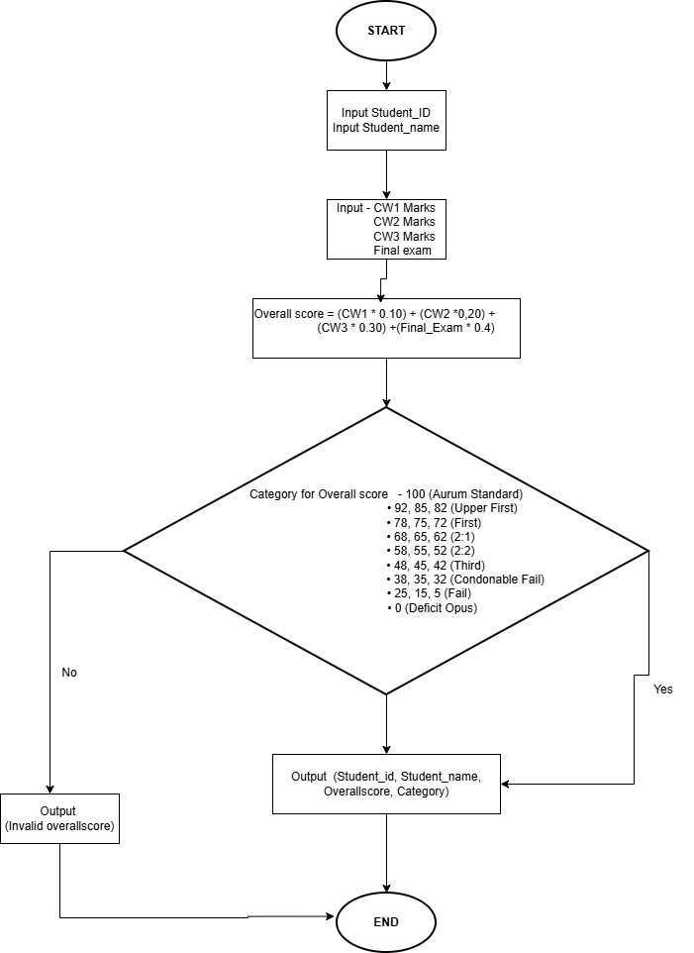

Task 3: Self-Reflection
When I started this coursework, I’m so excited because it was one of the first times I was writing a complete Python program that calculates students marks and assign them into categories. The coursework is that I could build something that reflects a real university grading system. I began the process by planning what the program should do and then designed a flowchart, and write the code.

- How I decomposed the problem
First, the program needed to collect inputs such as Student Id, the student name and marks for coursework 1, coursework 2, coursework 3, and the final exam. Next, I calculated the overall score using weighted percentages: (coursework 1 * 0.10), (coursework 2 * 0.20),(coursework 3 *0.30), and( final exam * 0.40). I then used the round() function to make the overall score a whole number for consistency. After that the program checked which range the overall score fell into and assigned the correct category, such as (Aurum Standard), (Upper First), (First), (2:1 Upper Second), (2:2), (Third), (Condonable Fail) and (Defecit Opus).

- Usefulness of the flowchart
The flowchart is very useful. I could clearly see how data would move from input to processing to output. I could refer back to the flowchart to follow my reasoning whenever I got lost or made a mistake. Because it made the process simple to follow, it also helped me in communicating my strategy to others. Because it shows me to consider each step logically, I found that creating a flowchart before coding saves time.

- Challenges and bugs encountered
Making sure the score ranges were correct and that boundary values were included was one of the most difficult tasks. When I first started using comparison operators like > and <, students who scored precisely at the range limits experienced errors. I resolved this by substituting >= and <=. Additionally, I made a small mistake by failing to round the total score, resulting in decimal values such as 86.5 instead of 86. Another problem was a typo that led to a NameError: cousework was written instead of Coursework. I also face the error in showing the overall score to the nearest value such as if the overall score is 40 then it doesn’t show the 42 and the related category properly that was the biggest challenge than I write down the proper format of if, elif, and else conditions to categorize the overall score to the nearest number.

- What I learned
I learned that programming isn’t just about writing code—it’s about logical thinking and planning. I became more comfortable with functions like input(), int(), round() and loop repeats all the following code for each student. I also understood how weighted averages work in practice and how conditional statements (if, elif, else) help in decision-making.

Overall, this coursework1 made me feel confident. It helped me realize that even a simple program can perform useful, real-world tasks. I started with an idea and ended with a grading system that works perfectly. It was a great learning experience that improved both my Python skills and my logical thinking.

